**Answer no = 1**

Graph – A = shown the outlier , the plot that show points that are the far from line.

Graph – B = shown that the graph is skewed(not symmetric)

Graph – C = shown a bimodal distribution.

Graph – D = shown a nearly normal distribution

**Answer no = 2**

Point 1 = True – if the sample size less than 30 then normal distribution may not be appropriate model for the distribution

Point no = 2- True standard error of daily average equal to 1

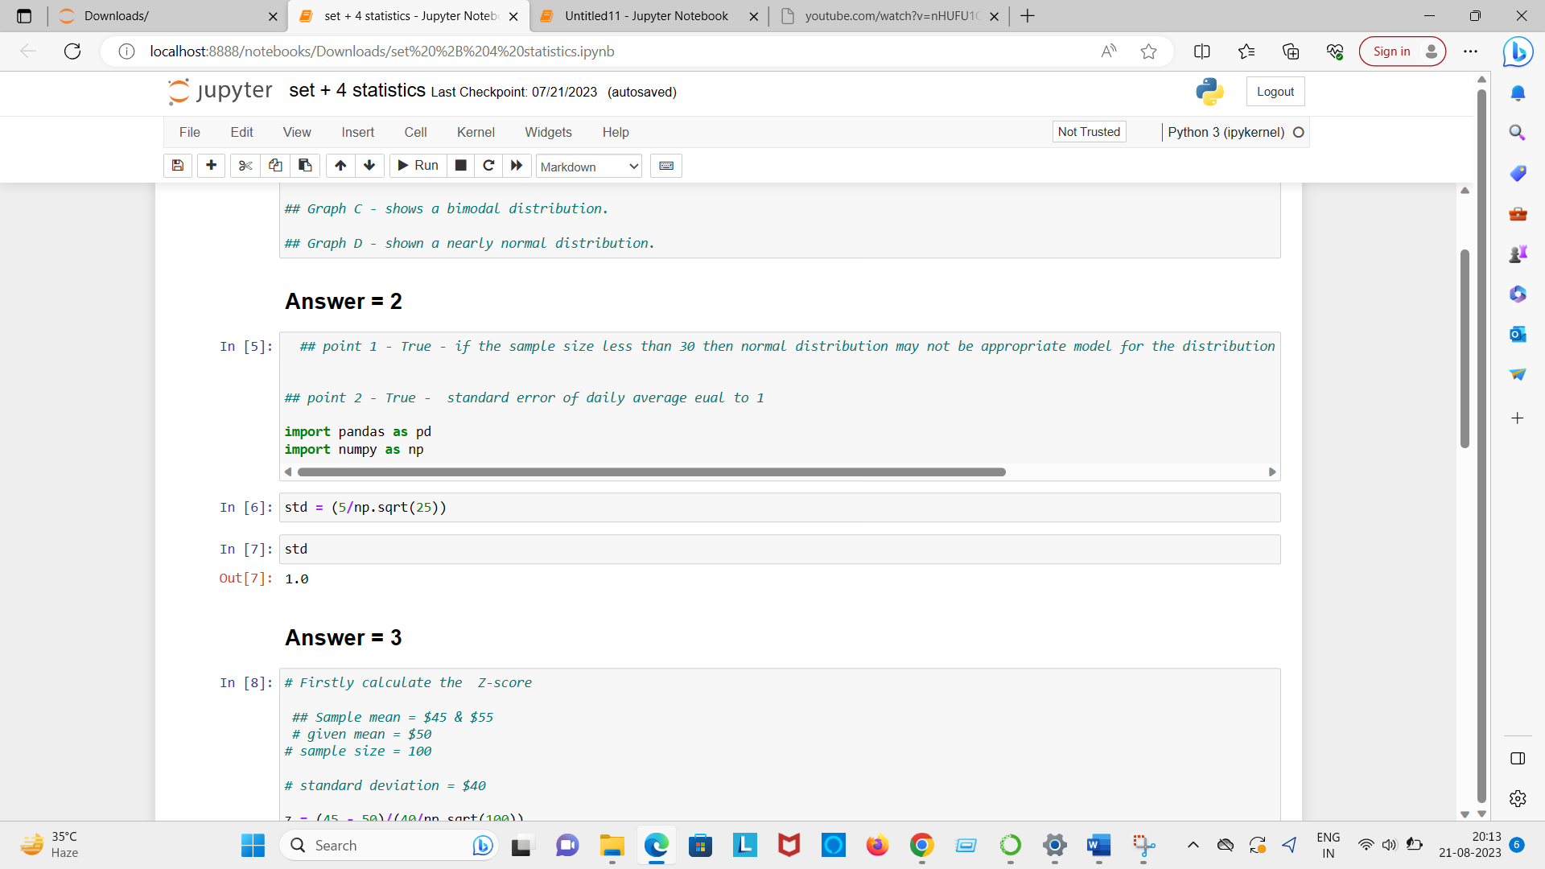

**Answer no - 3 = C.) 10.55% shown below in jupyter notebook:**

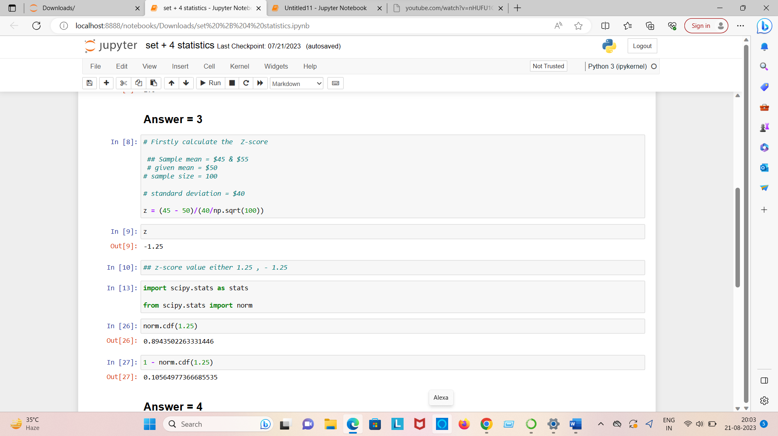

**Answer no – 4 = D.)**

**Explain in jupyter notebook screen shot shown below:**

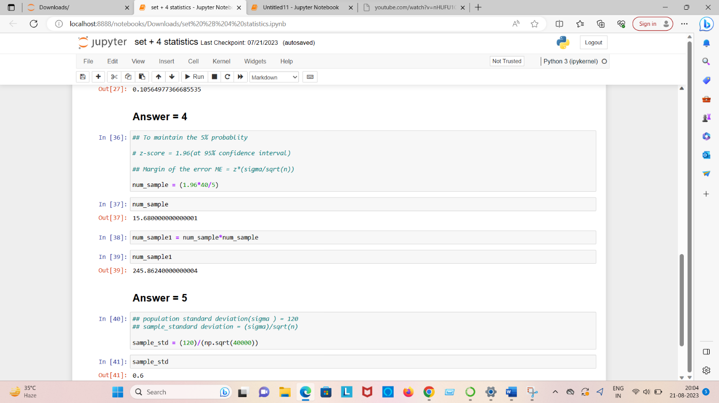

**Answer no = 5 = 0.60**